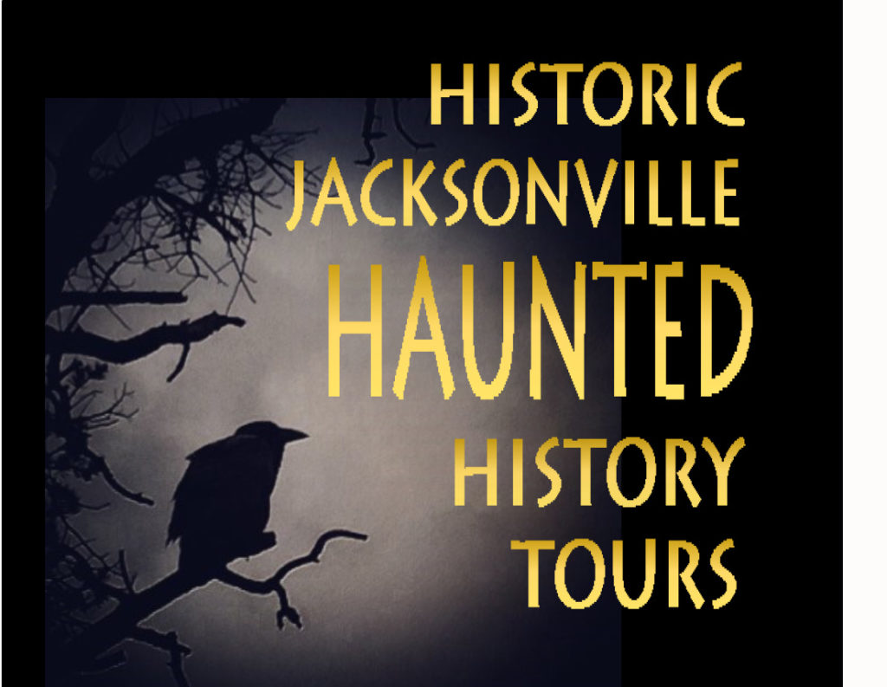

RATTLE YOUR FAVORITE PARTNER AND FELLOW ROTARIANS AND JOIN US FOR A HOWLING GOOD TIME!

Our own RYAN HESS will be our guide and sharing both history and tales of pioneers whose spirits still dwell in many of jacksonville’s historic buildings.

This tour is not your typical ‘ghost tour’ with special effects. They are history tours about real hauntings resulting from past events. The stories—some scary, some benign—come from multiple sources, from people who have experienced these lingering spirits. They are our attempt to recognize and honor these restless souls.

FRIDAY, OCTOBER 15TH @ 6:00 P.M.
MEET @ THE JACKSONVILLE VISITOR’S CENTER
(corner of N. Oregon & W. C Streets)
$15 pp (RSVP Required 775-771-8212)

